# Test Screenshots of All Methods

## GET

* GET /users – Fetch the list of all users.

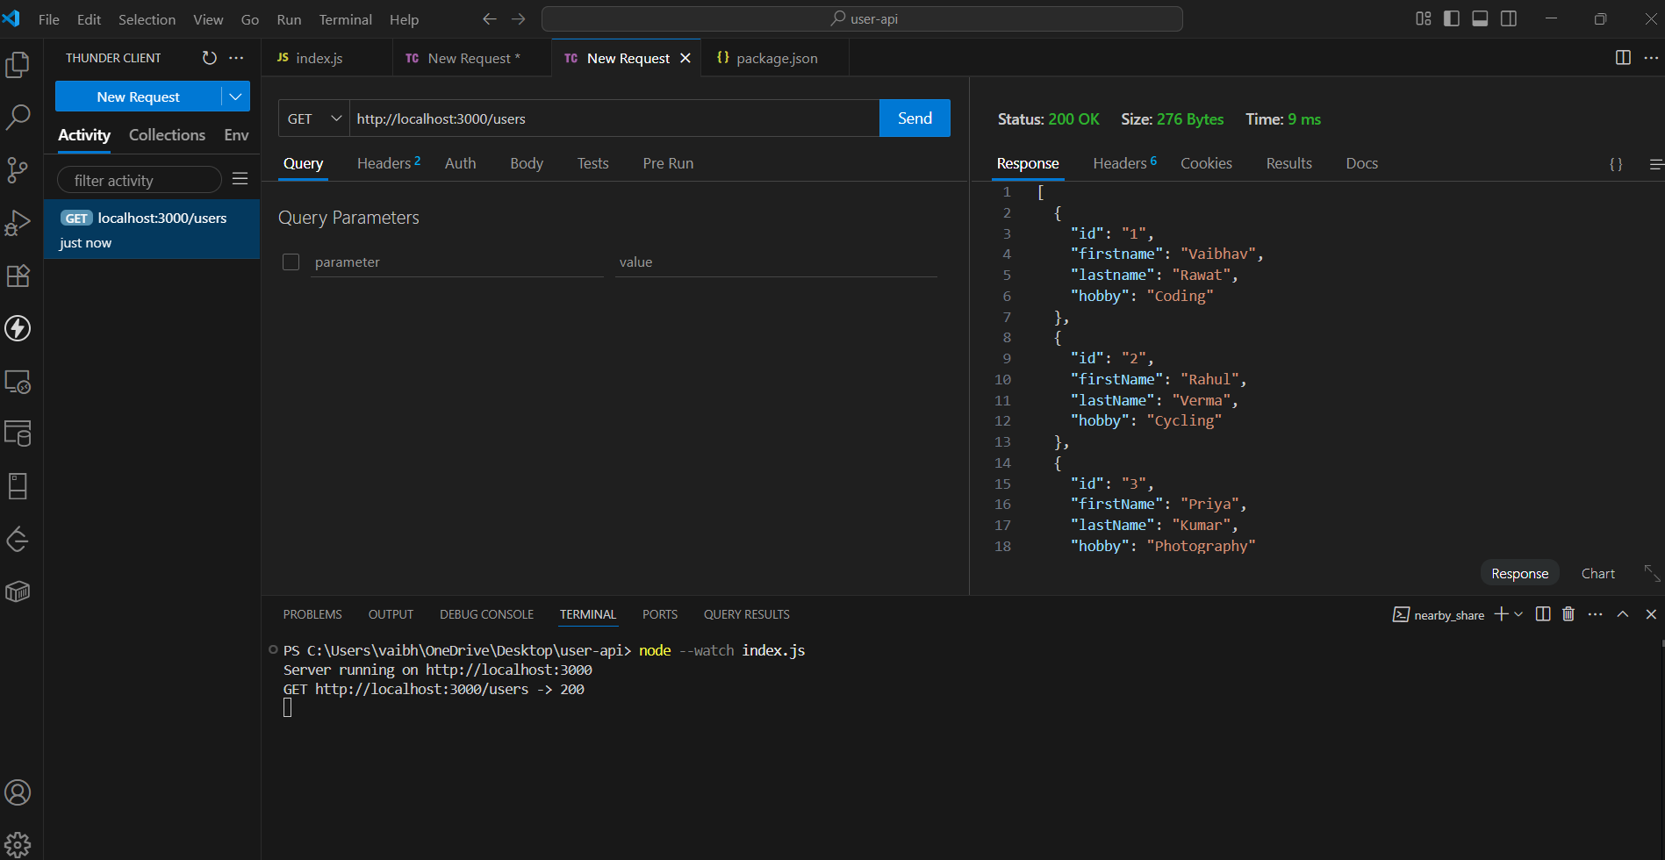

* GET /users/:id – Fetch details of a specific user by ID.

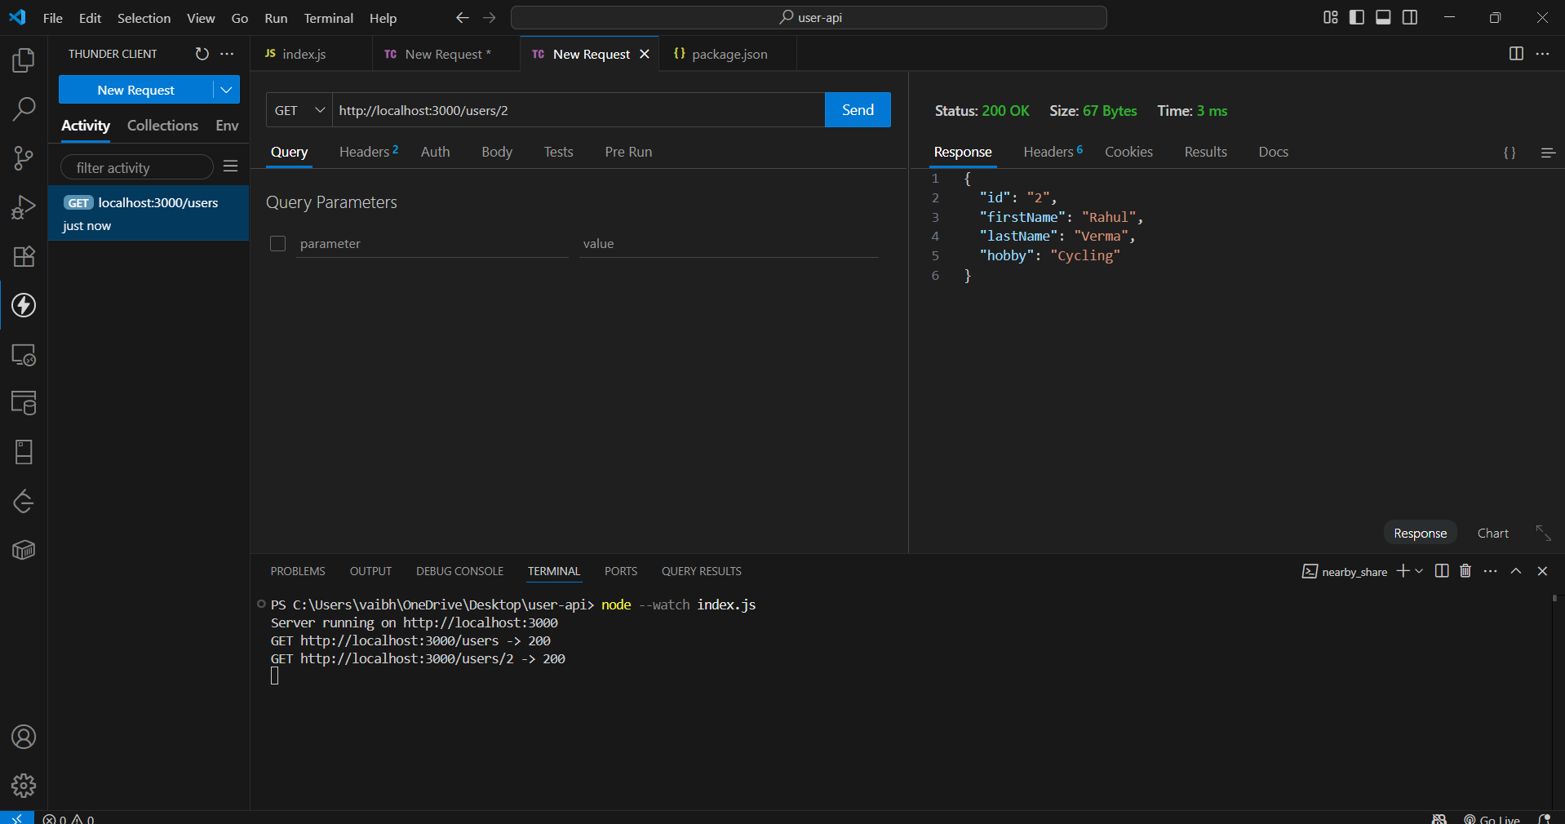

## Error while GET user by ID

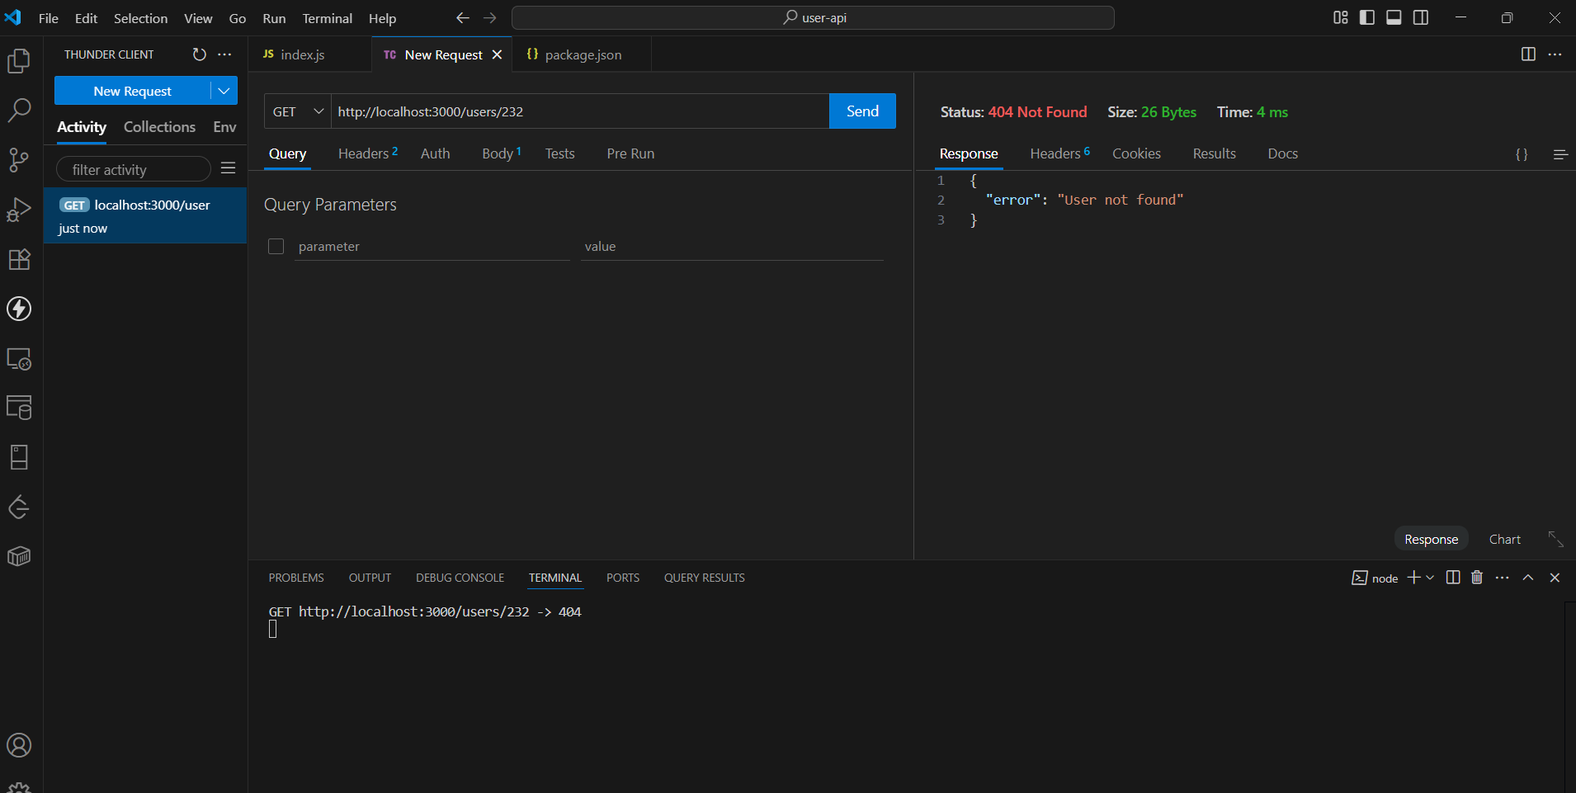

## POST Method

* POST /user – Add a new user. Success

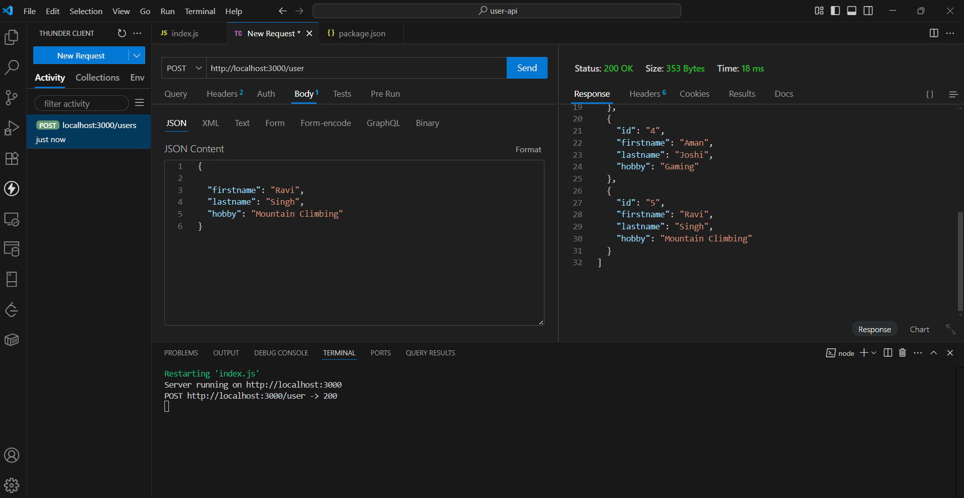

Errors While POST:

* Missing fields

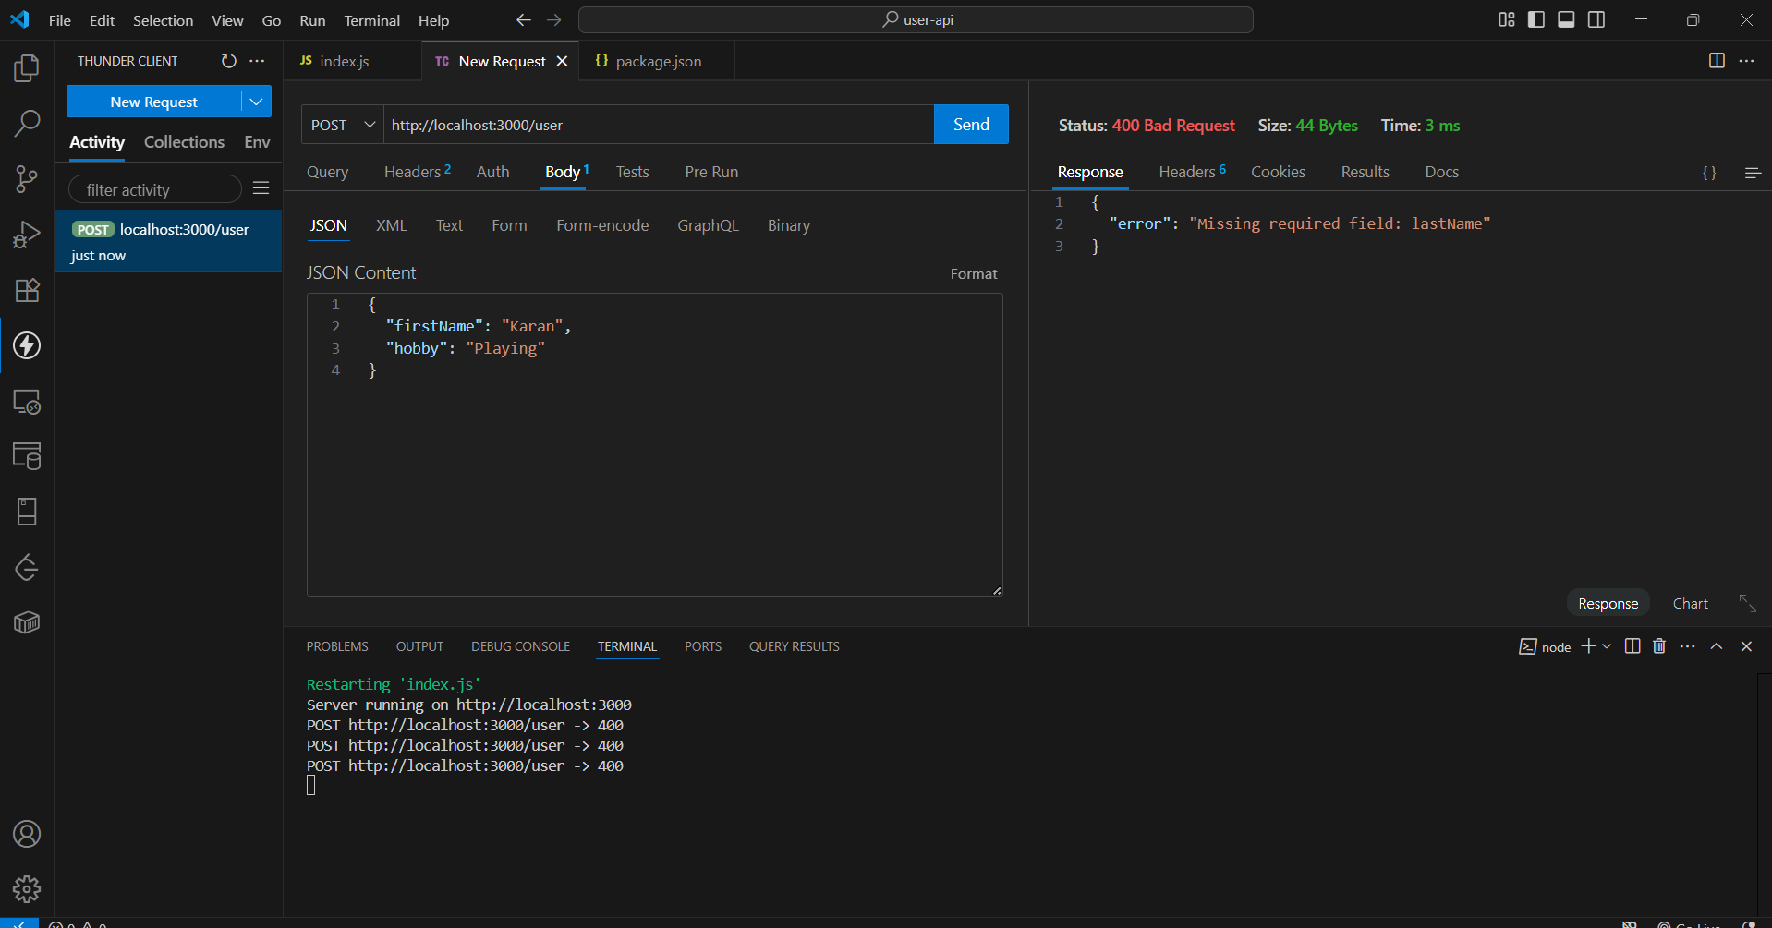

* Invalid fields

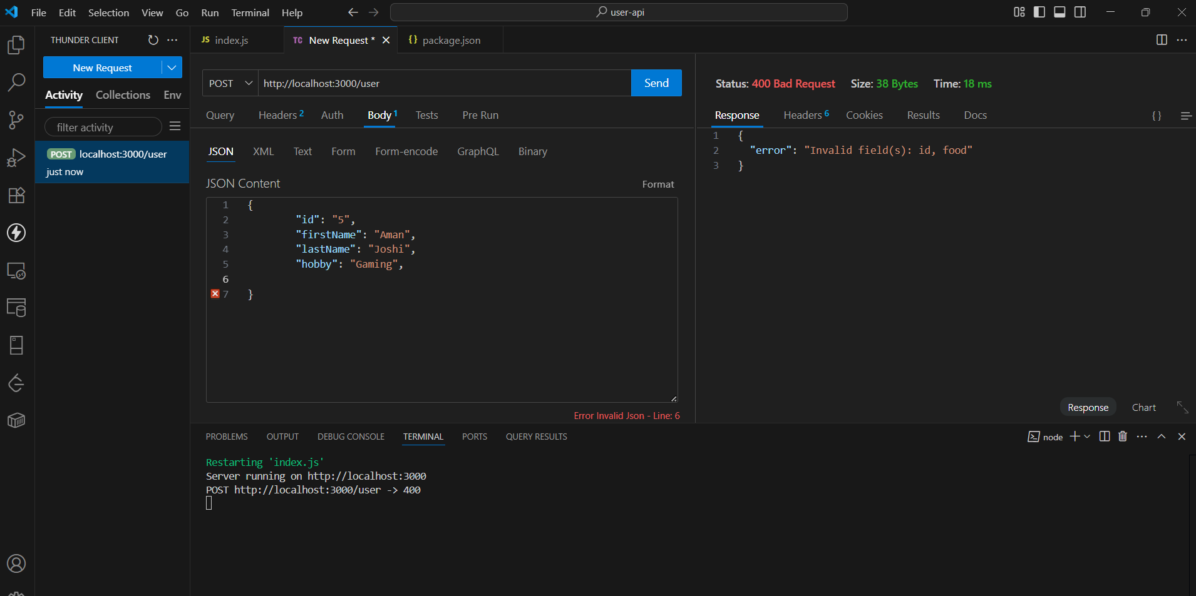

## PUT Method

* PUT /user/:id – Update details of an existing user. Success

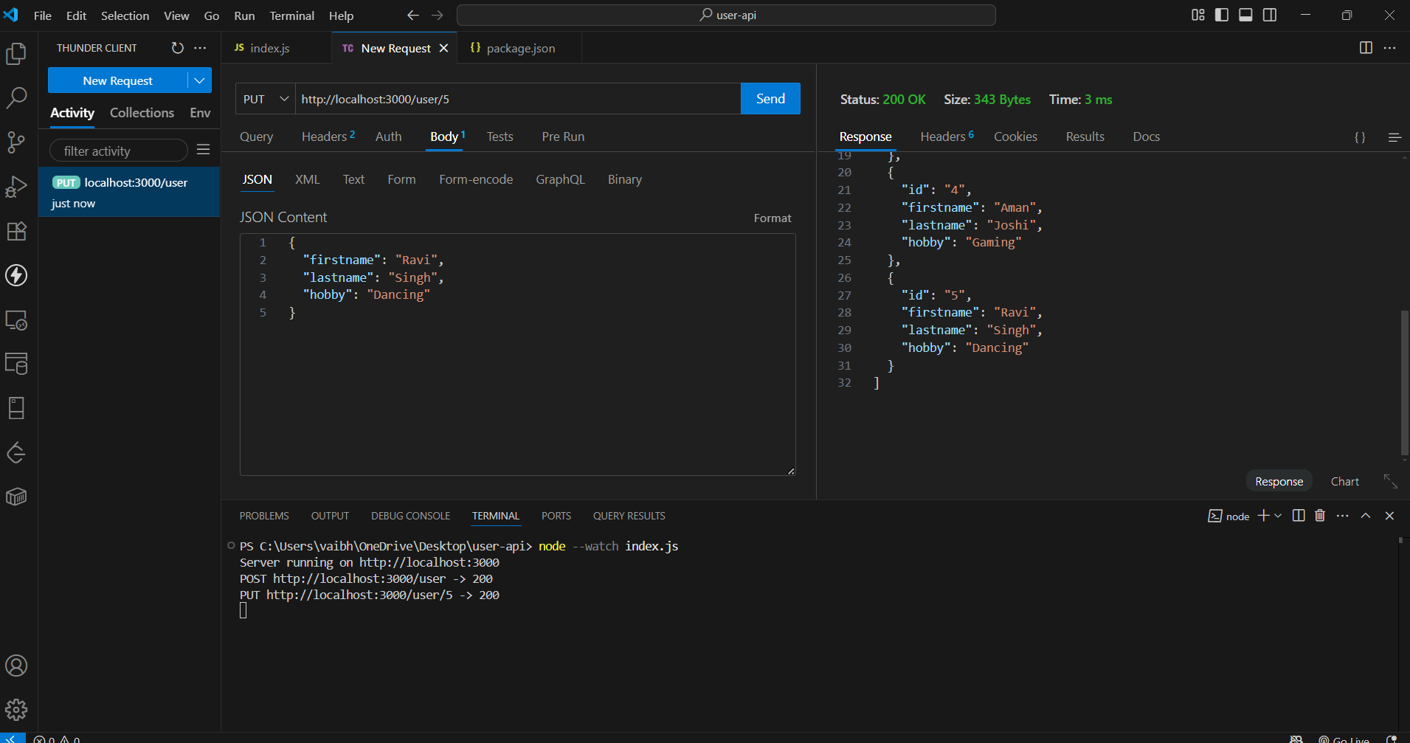

## Errors while PUT:

* Invalid fields

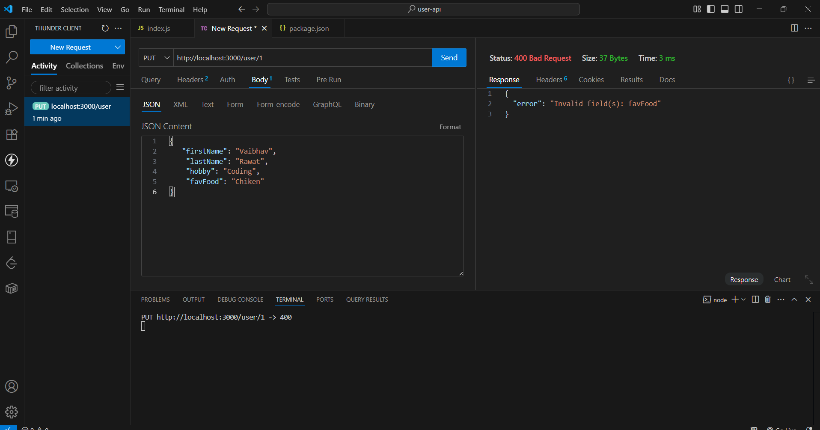

* Missing fields

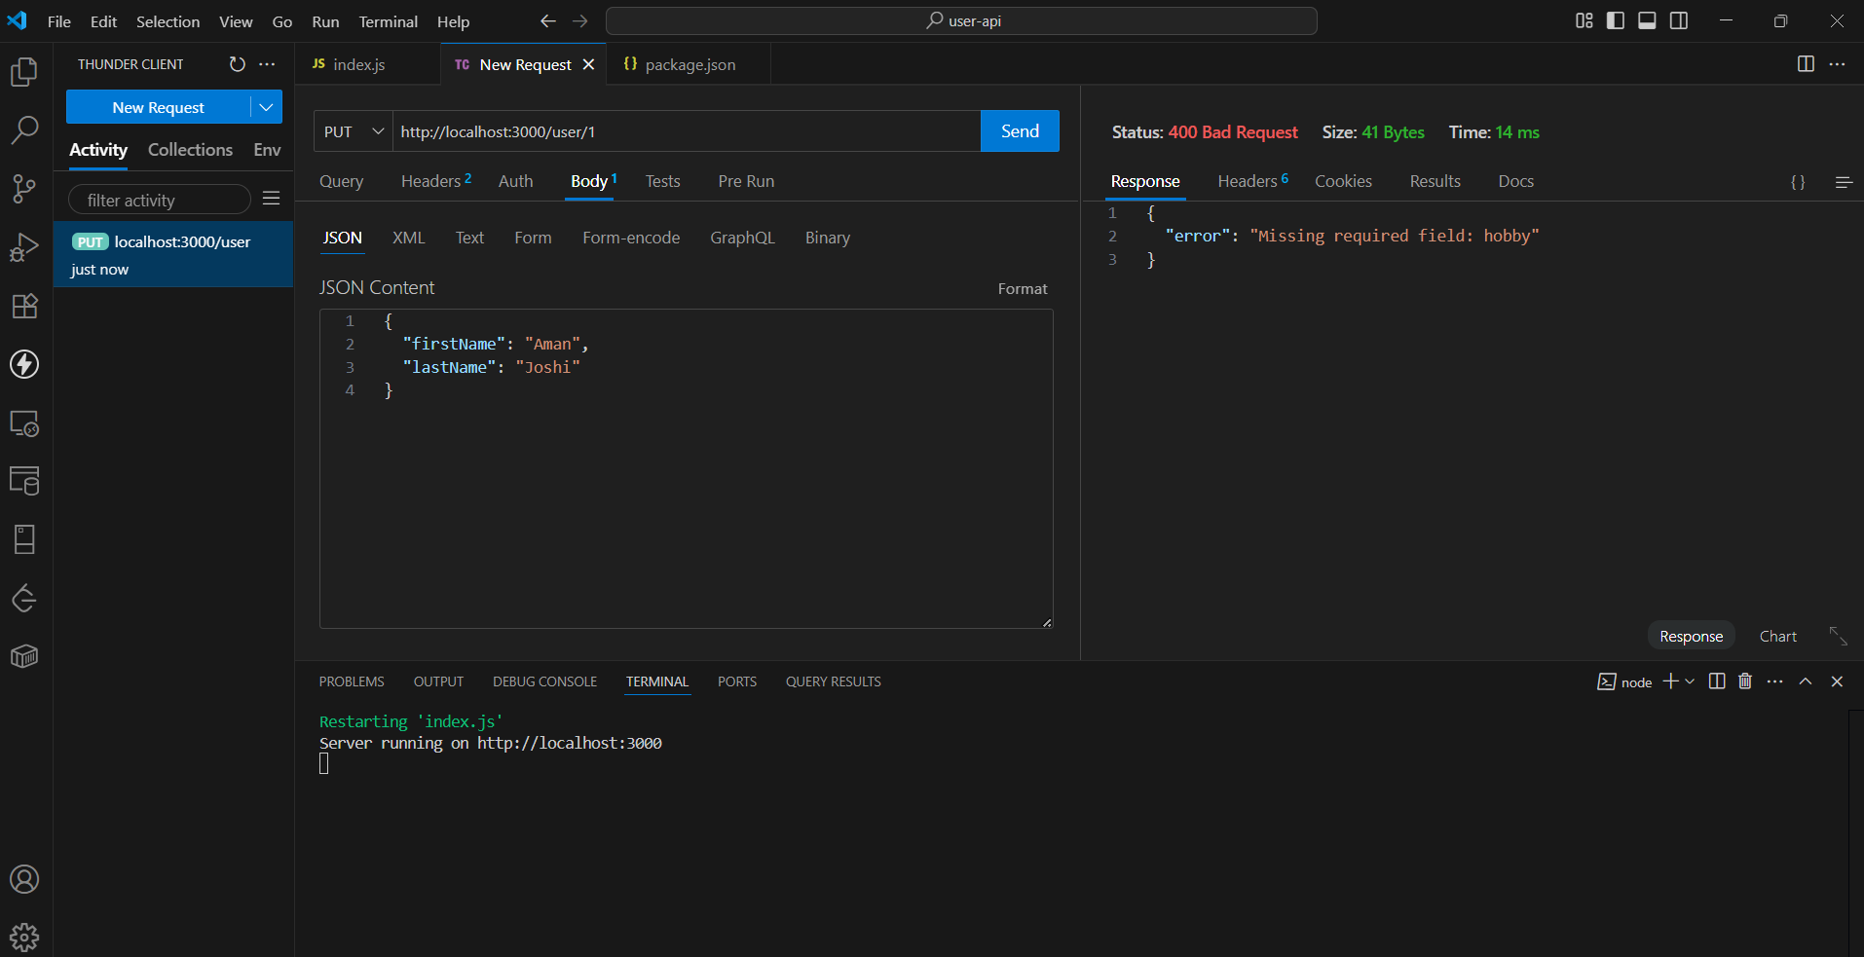

* User not found

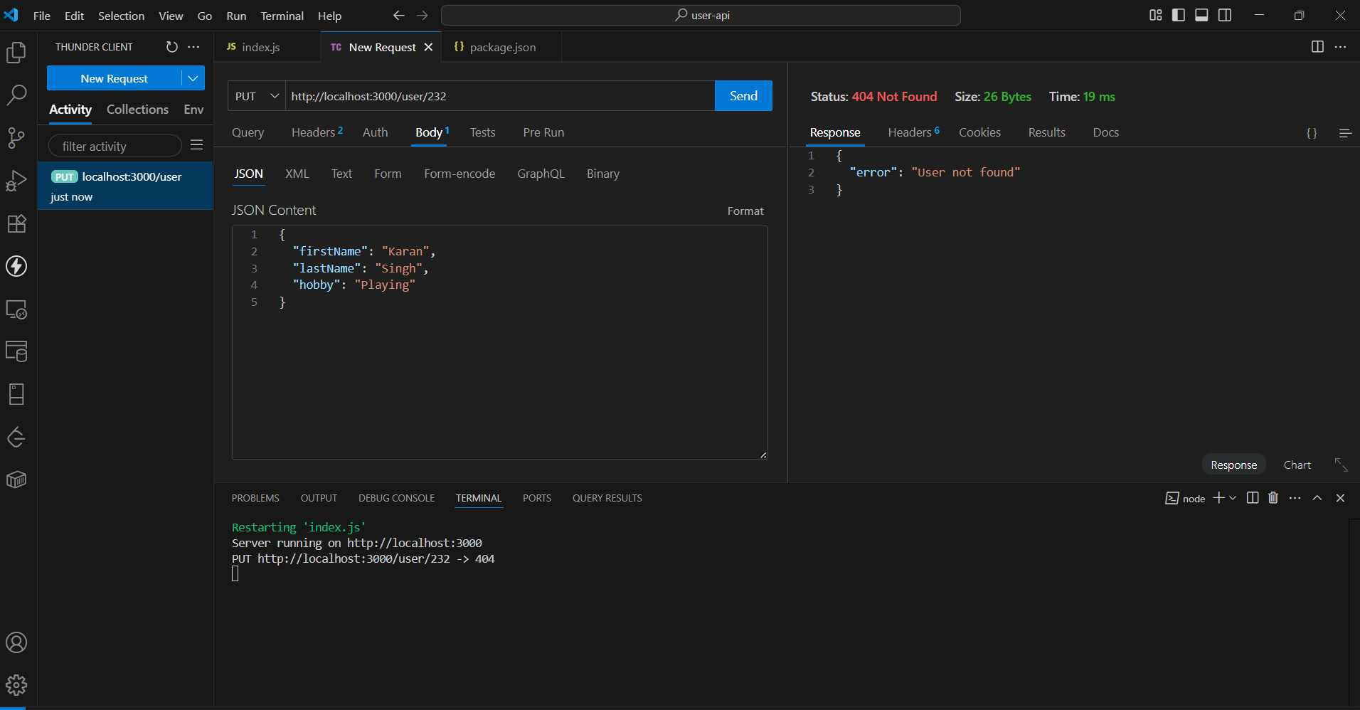

## DELETE Method

* DELETE /user/:id – Delete a user by ID.
  + Success and displaying the deleted user

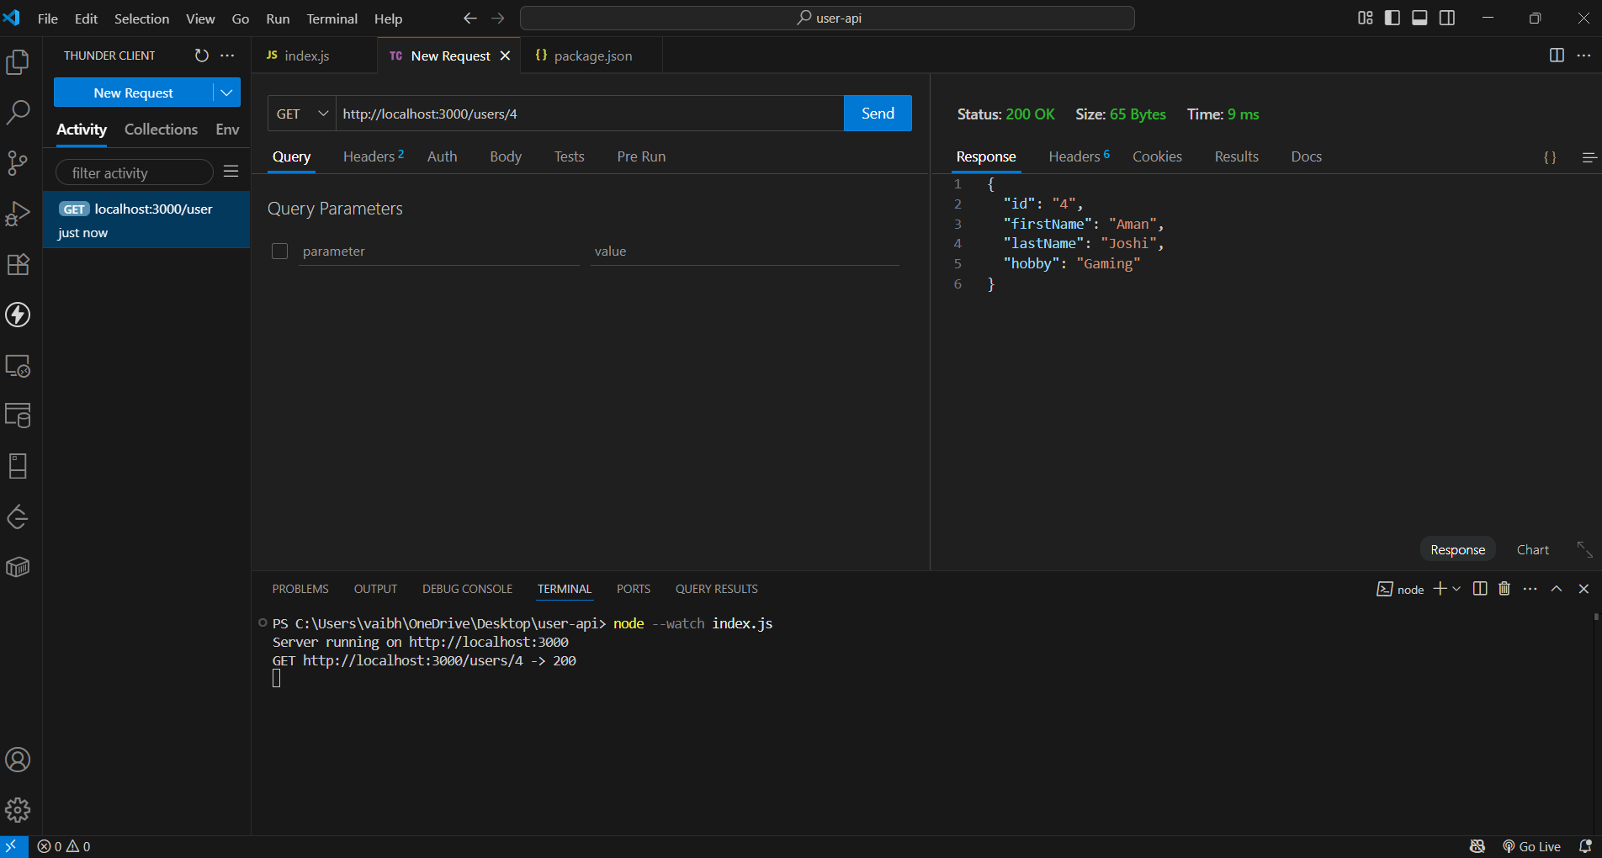

Now when we GET all users only 3 users left

